EXPT NO: 5 | IMPLEMENTATION OF A RECURRENT NEURAL NETWORK (RNN) FOR TEXT GENERATION
DATE:

PRE-LAB QUESTIONS (PROVIDE BRIEF ANSWERS TO THE FOLLOWING QUESTIONS)

Midhun P 24BAD069

- Explain the purpose of a Recurrent Neural Network (RNN) in processing sequential data.

A Recurrent Neural Network (RNN) is a neural network designed to process sequential data. It processes inputs in a particular order and maintains a hidden state to remember information from previous inputs. This previous information is used along with the current input to produce the next output. RNNs are useful for data where the order of information is important. They are commonly used for text, speech, and time-series data.

- Why is an RNN considered an appropriate model for text generation tasks?

RNNs are appropriate for text generation because text consists of words arranged in a specific sequence. An RNN uses information from previously processed words to predict the next word. After predicting a word, it can be added to the sequence and used to predict another word. This process can be repeated to generate longer text. Therefore, RNNs can learn sequential patterns and relationships in text.

- Describe the concept of sequence modeling in natural language processing.

Sequence modeling is the process of learning patterns and relationships from ordered data. In Natural Language Processing, the order of words is important for understanding the meaning of a sentence. A sequence model uses previous words or tokens to predict or process upcoming words. For example, it can predict the next word based on a sequence of previous words. RNNs are commonly used for such sequential language tasks.

- Explain the importance of tokenization during text preprocessing for RNN-based text generation.

Tokenization is the process of dividing text into smaller units called tokens, such as words. For example, the sentence "I love AI" can be divided into "I", "love", and "AI". These tokens are then assigned numerical values using a vocabulary. This converts the original text into a form that can be processed by the RNN. Therefore, tokenization is an important step in text preprocessing.

- Explain the significance of converting text into numerical representations before training an RNN.

An RNN cannot directly process raw textual words, so text must be converted into numerical representations. Each word is assigned a unique integer index based on the vocabulary. These indices can then be converted into dense vectors using an Embedding layer. The numerical representations allow the neural network to perform mathematical operations on the text. This enables the RNN to learn patterns and predict the next word.
AIM
To implement a Recurrent Neural Network (RNN) for text generation and evaluate its ability to generate meaningful text by predicting the next word in a sequence.

SOFTWARE REQUIREMENTS
- Python
- TensorFlow or keras or PyTorch
- Google Colab
- GitHub
- Numpy
- Matplotlib

PROCEDURE
TASK A: DATASET PREPARATION
Perform the following tasks:
- Load the Tiny Shakespeare dataset from Hugging Face.
- Explore the dataset and examine the text samples.
- Convert the text into lowercase (if required).
- Tokenize the text into individual words.
- Build a vocabulary and assign a unique integer index to each word.
- Generate input sequences for next-word prediction.
- Apply sequence padding to obtain inputs of equal length.
- Split the prepared sequences into training and validation datasets.

(CODE: CONATAINS STUDENT ROLL NOS
SCREENSHOT OF CODE
SCREENSHOT OF OUTPUT)
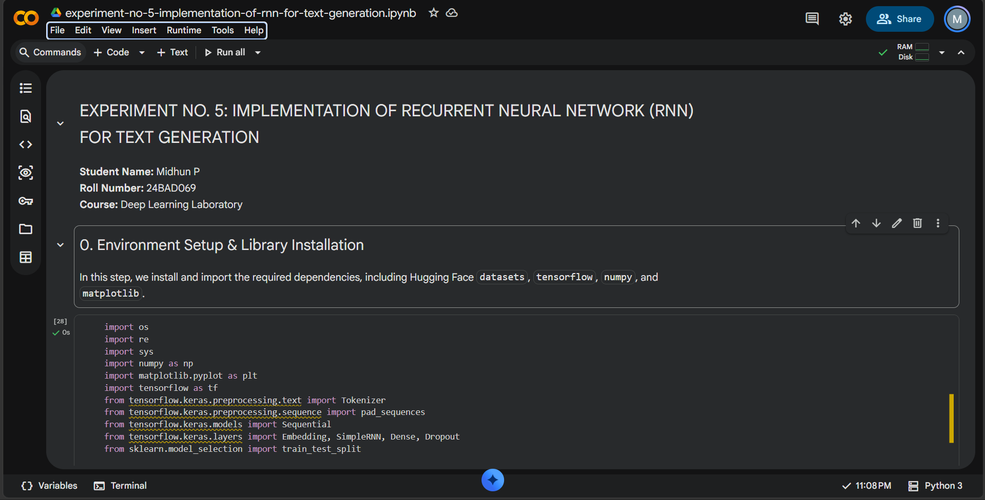

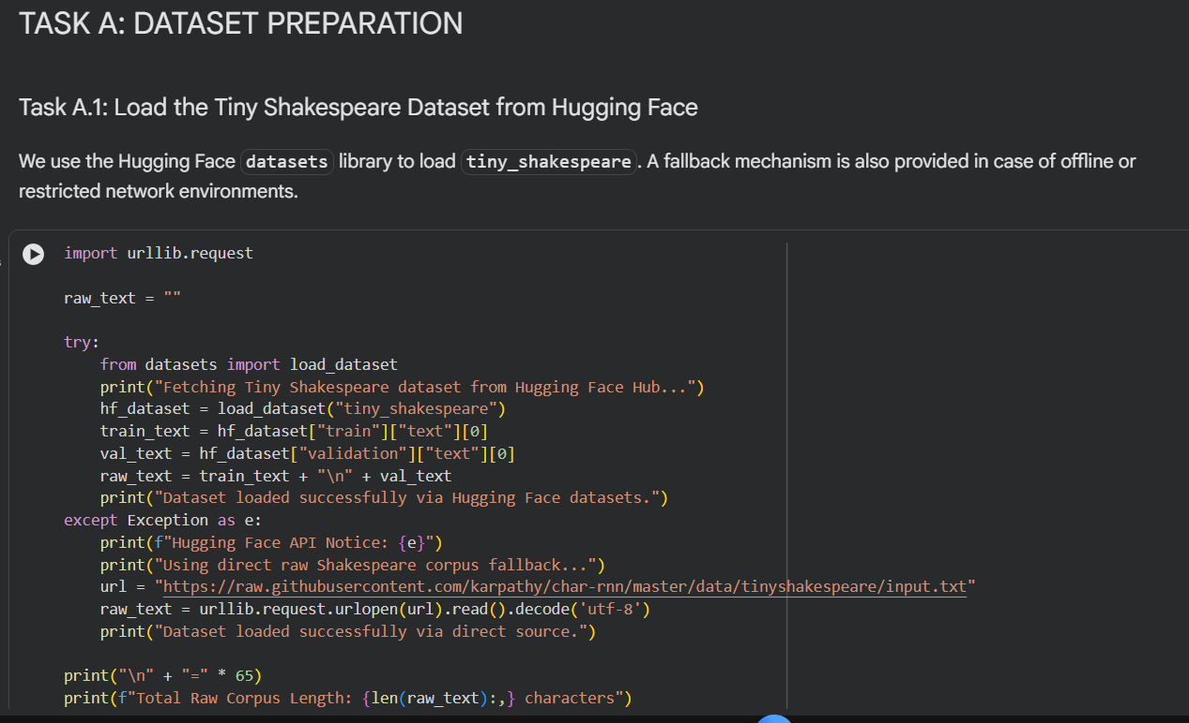

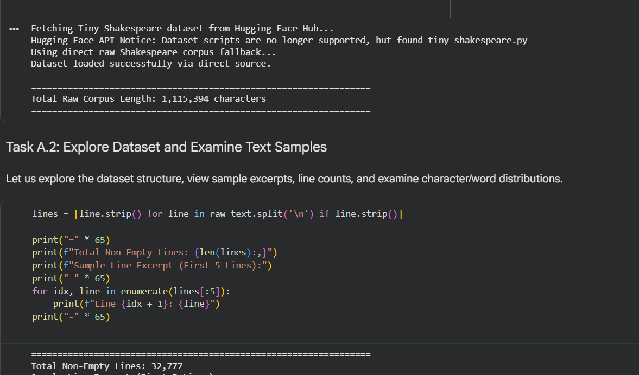

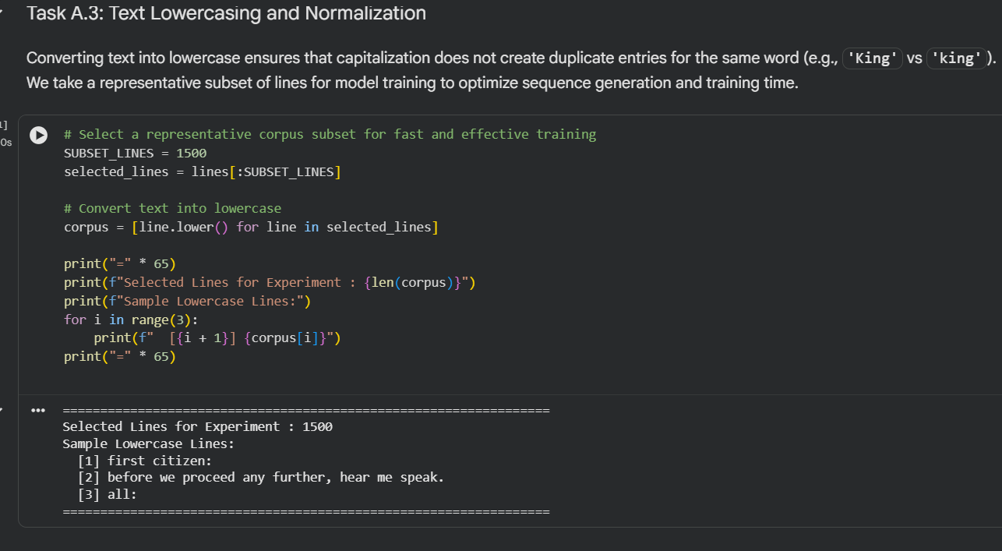

TASK B: IMPLEMENTING THE RNN MODEL
Perform the following tasks:
- Create an Embedding layer to convert words into dense vector representations.
- Add a Simple RNN layer to learn sequential dependencies in the text.
- Add a Dense output layer with Softmax activation for next-word prediction.
- Compile the model using an appropriate optimizer and loss function.
- Display the model architecture and summary.

(CODE: CONATAINS STUDENT ROLL NOS
SCREENSHOT OF CODE
SCREENSHOT OF OUTPUT)
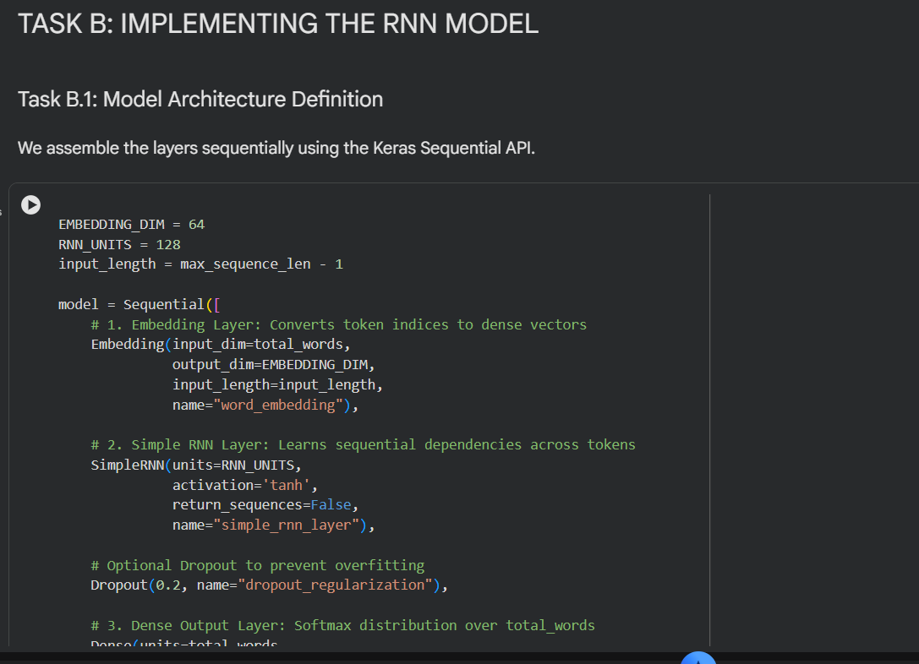

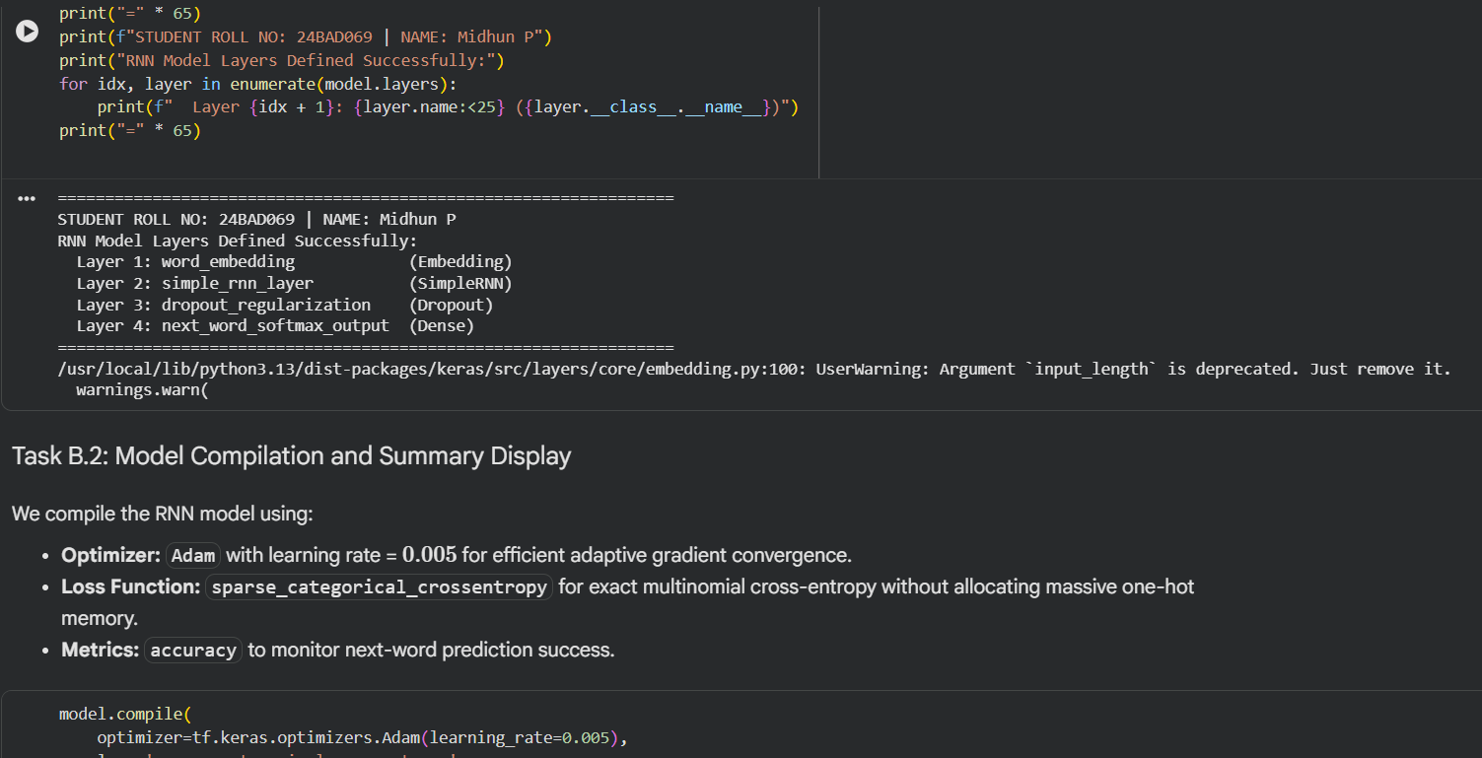

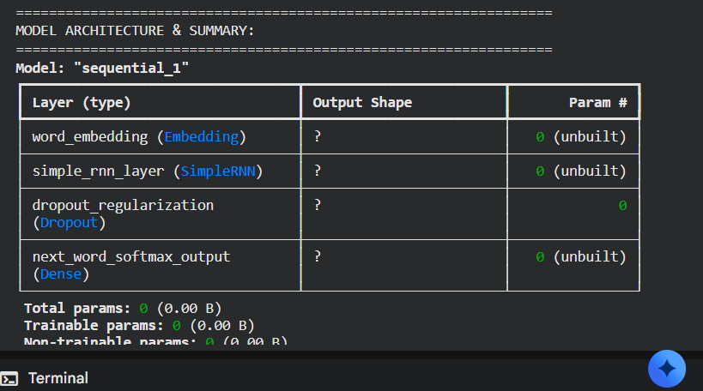

TASK C: RNN MODEL TRAINING AND PERFORMANCE EVALUATION
Perform the following tasks:
- Train the RNN model using the prepared training dataset.
- Validate the model using the validation dataset.
- Record:
  - Training accuracy
  - Validation accuracy
  - Training loss
  - Validation loss
- Visualize:
  - Accuracy vs. Epoch
  - Loss vs. Epoch

(CODE: CONATAINS STUDENT ROLL NOS
SCREENSHOT OF CODE
SCREENSHOT OF OUTPUT)
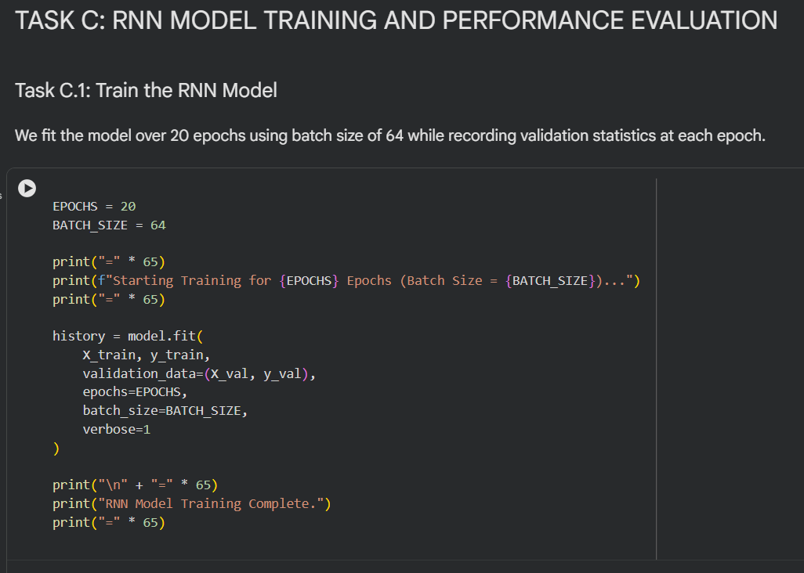
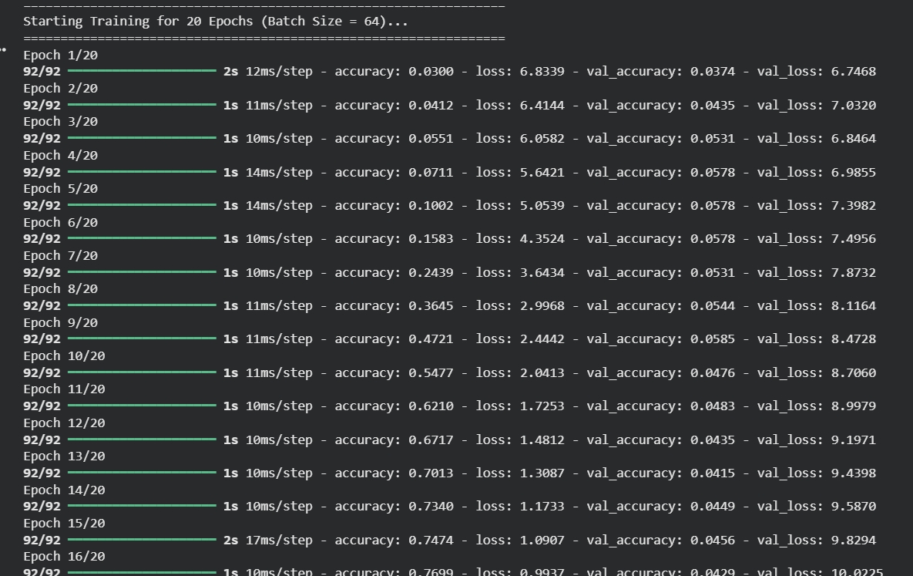
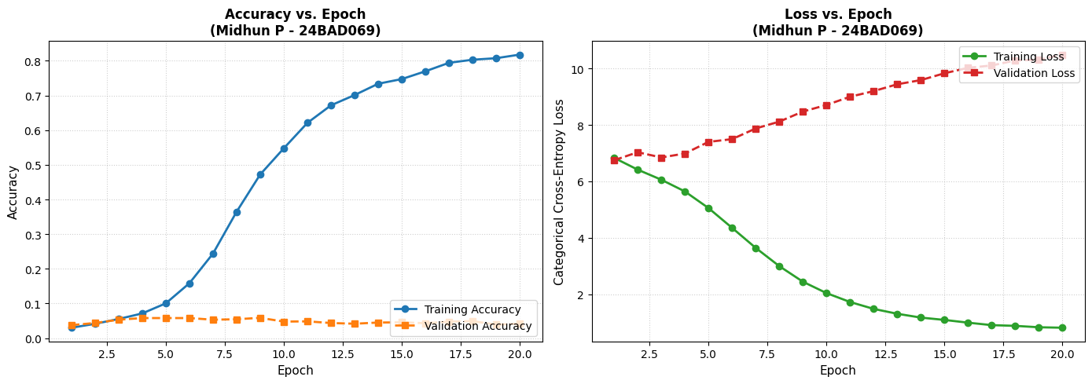
TASK D: DEEP LEARNING EXPERIMENT MANAGEMENT
Perform the following tasks:
- Provide a seed word or sentence as input to the trained model.
- Generate text by repeatedly predicting the next word in the sequence.
- Produce multiple text samples using different seed inputs.
- Compare the generated text for coherence and contextual relevance.
- Document the observations and upload the notebook to GitHub.

(CODE: CONATAINS STUDENT ROLL NOS
SCREENSHOT OF CODE
SCREENSHOT OF OUTPUT)

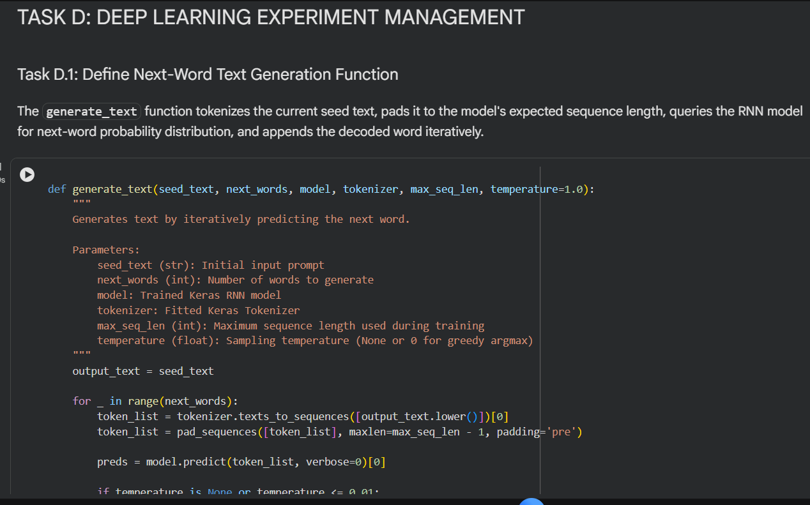

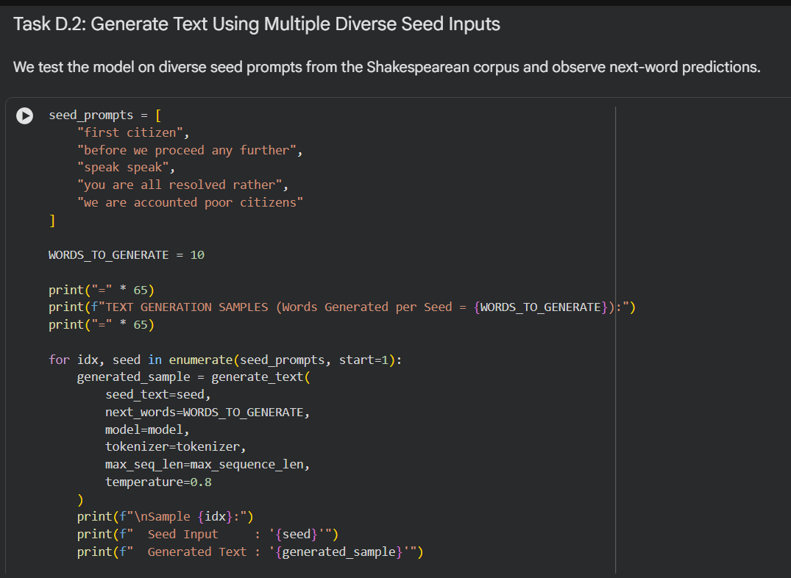
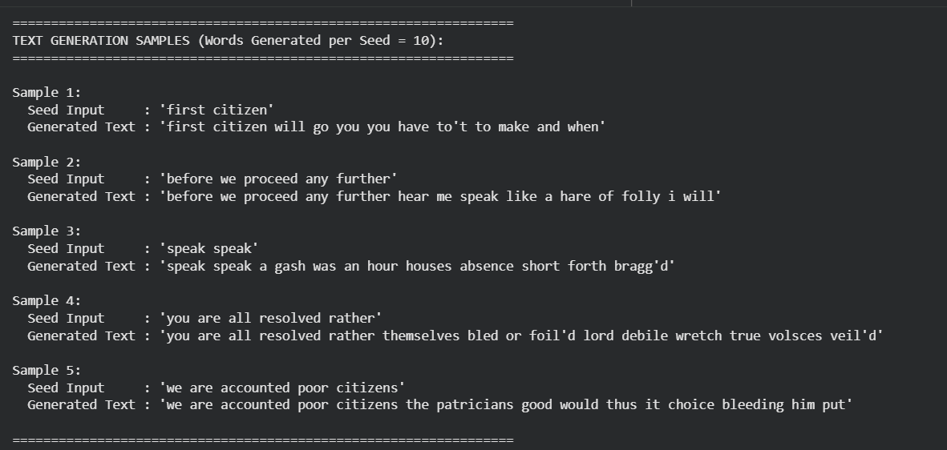

POST-LAB QUESTIONS (PROVIDE BRIEF ANSWERS TO THE FOLLOWING QUESTIONS)

- Describe the role of the hidden state in an RNN during sequence processing.

The hidden state acts as a memory of an RNN during sequence processing. It stores useful information from previously processed inputs and carries it to the next time step. The current input and previous hidden state are used to calculate a new hidden state. This allows the model to consider previous context while processing the current input. Therefore, the hidden state helps the RNN learn relationships between elements of a sequence.

- Discuss the effect of training an RNN model for an insufficient number of epochs.

An epoch represents one complete pass through the training dataset. If an RNN is trained for too few epochs, it may not learn the important patterns in the training text properly. This can result in higher loss and lower accuracy during training. The model may also produce less meaningful or coherent text during generation. Therefore, sufficient training is required for the model to learn useful text patterns.

- Explain the purpose of padding when preparing text sequences for RNN training.

Padding is used to make sequences of different lengths equal in size. Shorter sequences are filled with additional values, usually zeros, so that they have the same length as longer sequences. This allows multiple sequences to be processed together efficiently in batches. Padding does not add meaningful text information to the sequence. It mainly ensures that the input data has a consistent shape for RNN training.

- Discuss one limitation of a Simple RNN when processing long text sequences.

One limitation of a Simple RNN is its difficulty in remembering information from earlier parts of a long sequence. This occurs mainly because of the vanishing gradient problem during training. As the sequence becomes longer, important information from earlier time steps may be lost. Consequently, the model may have difficulty learning long-term dependencies. This can reduce the quality of predictions when processing long text.

- Discuss the effect of sequence length on the performance of the text generation model.

Sequence length determines how much previous context is provided to the RNN for predicting the next word. A shorter sequence requires less computation but provides less contextual information. A longer sequence provides more context and may help the model learn relationships between words. However, longer sequences require more computational resources and can be harder for a Simple RNN to process. Therefore, an appropriate sequence length is important for achieving good text-generation performance.

ASSESSMENT
Description | Max Marks | Marks Awarded
Pre Lab Exercise | 5
In Lab Exercise | 10
Post Lab Exercise | 5
Viva | 10
Total | 30
Faculty Signature

